

CST2213 BUSINESS INTELLIGENCE PROGRAMMING -2 ADVANCED CONCEPTS
Project Phase 2: Data Preparation & Initial Analysis

- Data Cleaning and Preprocessing
In the Survey of Consumer Finances dataset, it was observed that the column YY1 (Respondent ID) was duplicated five times due to applied imputation techniques on continuous variables, e.g. Income, Net Worth, Asset, Debt, etc.
There were no missing values observed from this dataset. Outliers and conversion of features were handled within the process of feature engineering.
- Data Integration and Transformation
  - Objective: Merge multiple datasets and transform them for analysis.
  - Tasks:
    - Integrate data from multiple sources into a single dataset.
    - Perform data transformations (e.g., aggregations, feature engineering).
    - Store processed data in a structured format .
  - Deliverables:
    - Integrated and transformed dataset.
    - Documentation of transformations applied.
This project utilizes only one dataset (Survey of Consumer Finances). Data was loaded into the notebook using pandas. It was then aggregated to a single respondent level (YY1) to reduce multiple imputations per respondent. Statistical methods were performed to the attributes below:
Attribute | Description | Statistical Method
AGECL | Age group of the reference person | Mode
EDCL | Education category of reference person | Mode
MARRIED | Marital status of reference person | Mode
KIDS | Total number of children in household | Mode
KNOWL | Respondent's knowledge of personal finances | Mode
OCCAT1 | Occupation categories for reference person | Mode
FAMSTRUCT | Family structure of household | Mode
HHSEX | Gender of household reference person | Mode
NOFINRISK | Respondent not willing to take financial risk | Mode
YESFINRISK | Respondent willing to take financial risk | Mode
ASSET | Total value of assets held by household, 2019 dollars | Mean
INCOME | Total amount of income of household, 2019 dollars | Mean
NETWORTH | Total net worth of household, 2019 dollars | Mean
EQUITY | Total value of financial assets held by household that are invested in stock, 2019 dollars | Mean
DEBT | Total value of debt held by household, 2019 dollars | Mean

- Exploratory Data Analysis (EDA)
The following information were obtained after analyzing the data:
  - Dataset dimension
    - There are 22,975 data points and 357 attributes.
  - Descriptive statistics
    - Numerical variables
 | ASSET | INCOME | NETWORTH | EQUITY | DEBT
count | 22975.000000 | 22975.000000 | 22975.000000 | 22975.000000 | 22975.000000
mean | 20317046.257824 | 1592855.207682 | 19956403.324635 | 5864321.191456 | 360642.933188
std | 110925570.288364 | 12442710.392028 | 110170716.217272 | 55440799.285854 | 2544356.013837
min | 0.000000 | 0.000000 | -555500.000000 | 0.000000 | 0.000000
25% | 63850.000000 | 42155.561122 | 35907.500000 | 0.000000 | 0.000000
50% | 539800.000000 | 94039.328657 | 384500.000000 | 17000.000000 | 29000.000000
75% | 2716900.000000 | 264823.396790 | 2476105.000000 | 475000.000000 | 217000.000000
max | 2387780900.000000 | 458230949.400000 | 2387780900.000000 | 1890230000.000000 | 131990000.000000

    - Categorical variables
 | ASSET | INCOME | NETWORTH | EQUITY | DEBT
count | 22975.000000 | 22975.000000 | 22975.000000 | 22975.000000 | 22975.000000
mean | 20317046.257824 | 1592855.207682 | 19956403.324635 | 5864321.191456 | 360642.933188
std | 110925570.288364 | 12442710.392028 | 110170716.217272 | 55440799.285854 | 2544356.013837
min | 0.000000 | 0.000000 | -555500.000000 | 0.000000 | 0.000000
25% | 63850.000000 | 42155.561122 | 35907.500000 | 0.000000 | 0.000000
50% | 539800.000000 | 94039.328657 | 384500.000000 | 17000.000000 | 29000.000000
75% | 2716900.000000 | 264823.396790 | 2476105.000000 | 475000.000000 | 217000.000000
max | 2387780900.000000 | 458230949.400000 | 2387780900.000000 | 1890230000.000000 | 131990000.000000

  - Visualizing distribution
    - Net Worth, Income, and Debt is right skewed. Most respondents were at the lower end of the distribution.
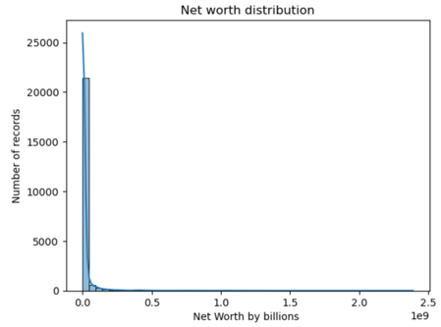
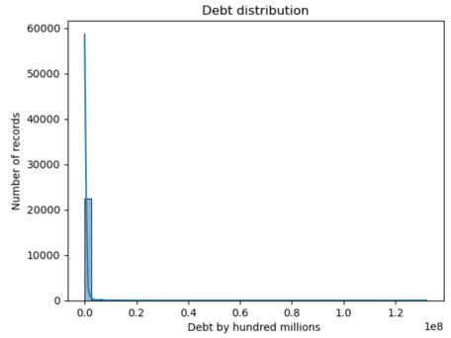
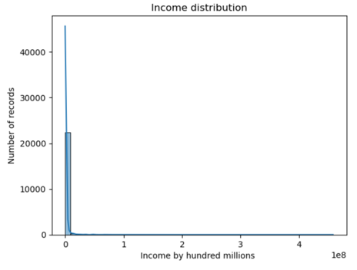

  - Correlation Matrix
    - Positive
      - INCOME, NETWORTH, ASSET, EQUITY (strong)
      - DEBT to INCOME, NETWORTH and EQUITY (moderate)
      - OCCAT1 (Occupational Category) to AGECL(Age Class) and EDCL(Education Class) (moderate)
    - Negative Correlation
      - EDCL (Education Classification) to NOFINRISK (No Financial Risk) (moderate)
      - KNOWL (Financial Knowledge) to NOFINRISK (No Financial Risk) (moderate)

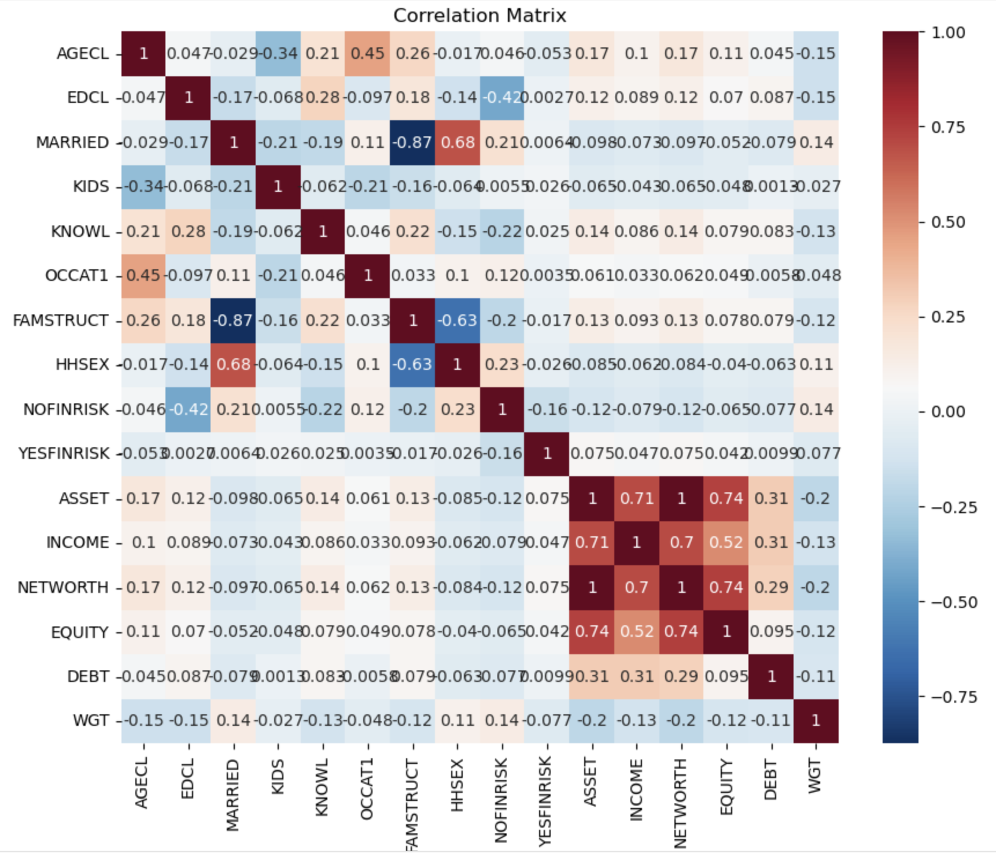

- Feature Selection and Engineering
  - Objective: Identify and create relevant features for further analysis.
  - Tasks:
    - Select key features using statistical tests or machine learning techniques.
    - Create new features based on domain knowledge.
    - Reduce dimensionality if needed.
  - Deliverables:
    - A refined feature set for modeling.
    - Justification for selected features.
  - Selected Key Attributes
    - YY1
    - AGECL
    - EDCL
    - MARRIED
    - KIDS
    - KNOWL
    - OCCAT1
    - FAMSTRUCT
    - HHSEX
    - NOFINRISK
    - YESFINRISK
    - ASSET
    - INCOME
    - NETWORTH
    - EQUITY
    - DEBT
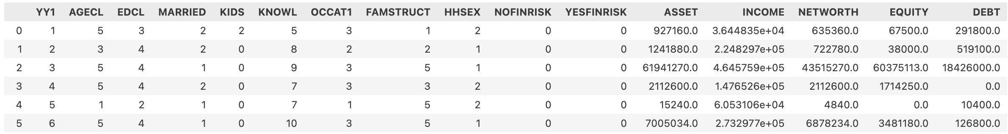

  - Derived Attributes
    - Knowledge Group (categorical)
    - Metrics
      - Equity to Asset Ratio (numerical)
      - Debt to Asset Ratio (numerical)
      - Debt to Income Ratio (numerical)
      - Equity to Asset Score (numerical)
      - Debt to Asset Ratio Score (numerical)
      - Debt to Income Ratio Score (numerical)
      - Risk Profile (categorical)

- Preliminary Insights and Hypothesis Testing
  - Objective: Validate initial assumptions and refine the research approach.
  - Tasks:
    - Perform hypothesis testing on key relationships.
    - Identify patterns and trends that can be used for predictive modeling.
    - Adjust project scope based on findings.
  - Deliverables:
    - A report summarizing initial insights.
    - Recommendations for further analysis in the next phase.

Submission for Phase 2
- Required Deliverables:
  - Data cleaning and preprocessing report.
  - Integrated dataset with transformation documentation.
  - Exploratory Data Analysis report with visualizations.
  - Feature selection and engineering documentation.
  - Summary of preliminary insights and hypothesis testing results.

Project Phase 2: System Design & Development

- System Architecture Design
  - Objective: Define the system's structure and its components.
  - Tasks:
    - Identify system architecture.
    - Define data flow and interactions between system components.
    - Create UML diagrams (Use Case, ERD, Sequence Diagrams).
  - Deliverables:
    - System architecture document.
    - UML diagrams outlining key system interactions.
- Database Design
  - Objective: Design a structured database schema to store data efficiently.
  - Tasks:
    - Define tables, relationships, and constraints.
    - Normalize data to reduce redundancy.
    - Develop ERD (Entity Relationship Diagram).
  - Deliverables:
    - Database schema design.
    - SQL scripts for table creation.
- Frontend & Backend Development
  - Objective: Implement the core system functionalities.
  - Tasks:
    - Develop frontend.
    - Implement backend.
    - Connect frontend and backend.
  - Deliverables:
    - Initial frontend and backend implementations.
    - API documentation.
- Feature Implementation & Integration
  - Objective: Develop and integrate key system features.
  - Tasks:
    - Implement authentication and authorization.
    - Set up data processing logic (e.g., reports, visualizations).
  - Deliverables:
    - Functional feature modules.
    - API testing results.
- Testing & Debugging
  - Objective: Ensure the system functions correctly before deployment.
  - Tasks:
    - Perform unit testing (e.g.,PyTest).
    - Conduct integration testing to verify module interactions.
    - Identify and fix bugs.
  - Deliverables:
    - Test cases and results report.
    - Bug tracking and resolution documentation.

Submission for Phase 2
- Required Deliverables:
  - System architecture and database design documents.
  - Initial frontend and backend implementations.
  - API documentation.
  - Feature implementation report.
  - Testing report and bug fixes.

Siju Philip

To create a Vanguard-style Risk Profile, we use a "Gatekeeper" logic. The Equity Ratio shows what they want to do, but the Solvency (D/A) and Liquidity (DTI) ratios determine if they are allowed to do it.
1. Weighted Scoring Logic
We assign "Risk Points" based on your three metrics. Higher points = Higher Risk Tolerance.
Metric | 0 Points (Low) | 1 Point (Mid) | 2 Points (High)
Equity Ratio | < 0.30 | 0.30 – 0.70 | > 0.70
Debt-to-Asset | > 0.40 | 0.10 – 0.40 | < 0.10
Debt-to-Income | > 0.40 | 0.20 – 0.40 | < 0.20
3. Why this works for Model Training
- Internal Consistency: By using this logic, you create a "Ground Truth" label that your model can learn to predict using the other features (Age, Education, Marriage, etc.).
- Balance: It identifies the "False Aggressives"—people who have a lot of stocks but are drowning in debt—and correctly labels them as Conservative because they lack the capacity to stay invested during a crash [5, 6].
- Non-Linearity: The safety override captures the "cliff" effect where extreme debt breaks standard investment logic.
4. Sources for these Logic Gates
- Vanguard Methodology: Prioritizes "Time Horizon" and "Financial Situation" as equal to risk appetite [1, 4].
- FINRA Guidelines: Explicitly states that high debt-to-income ratios reduce an investor's ability to take on market risk [4].
- SCF Research: Confirms that the "debt-burden" threshold (DTI > 40%) is the primary predictor of households selling off assets during downturns [3].
Should we proceed to the final step of encoding your demographic variables like AGECL and FAMSTRUCT to prep the data for the classifier?

Sources:
  - Vanguard: Choosing the Right Asset Mix - https://ownyourfuture.vanguard.com/content/en/learn/financial-planning/choose-the-right-asset-mix-for-your-financial-situation.html
  - Vanguard: Investor Questionnaire Scoring - https://workplace.vanguard.com/content/dam/inst/iig-transformation/offers/vrpa/pdf/participant-education-resources/investor-questionnaire.pdf
  - Federal Reserve Bulletin: Debt Burden in the SCF - https://www.federalreserve.gov/econres/scfindex.htm
  - FINRA: Key Investing Concepts – Risk - https://www.finra.org/investors/investing/investing-basics/risk
  - CIRO: Risk Capacity vs. Tolerance Definitions - https://www.ciro.ca/office-investor/understanding-risk

SCFP 2022 Codebook
https://www.federalreserve.gov/econres/files/codebk2022.txt

